Milestone 3. routes.py Development
In this milestone, the primary focus was on setting up all major FastAPI routes for the app, handling user inputs efficiently, integrating AI generation workflows, and ensuring smooth interaction between backend processing and frontend templates.
This step-by-step approach created a stable foundation for processing prompts, generating comics, and providing a seamless user experience.

Activity 3.1: Writing the Main Application Logic in routes.py

Defining Core routes in routes.py:
Separate routes were established for each of ComicCraft’s core functionalities:
- / → Loads the homepage (index.html) where users can submit their story details.
- /generate → Handles form submission, processes the input using AI, generates the comic panels, and returns the comic preview page.
- /generate-comic/json → An API route that accepts JSON payloads, triggers comic generation, and returns comic layout data and the generated PDF path.
- /export-success → Displays a success confirmation page after the comic is downloaded.
- /test-image → A developer utility route to test image generation from a direct prompt without full comic creation.
Each route serves as a distinct entry point for different types of user interaction — through browser forms or direct API requests.
Set up Route Handlers for Each Feature
Each route handler captures and processes user inputs using FastAPI’s form and request body mechanisms:
- For /generate, user inputs are captured using Form(...) parameters for:
  - Story prompt
  - Character name
  - Setting
  - Story tone
  - Art style
- For /generate-comic/json, inputs are captured from a JSON body using a PromptRequest model with Pydantic.
Form data and JSON payloads are correctly extracted and passed into backend functions (generate_outline, generate_story, generate_image, build_comic_layout, save_pdf) ensuring smooth AI processing based on user details.
The route handlers manage error handling via FastAPI’s HTTPException system and use try-except blocks to gracefully handle unexpected failures like API errors or JSON decode errors.
Integrate AI workflows in each Route
Within each relevant route, the core AI functionalities were integrated:
In /generate and /generate-comic/json:
  - generate_outline() is called to create a 5-panel structured story.
  - generate_story() is called to write narration and dialogues.
  - generate_image() is called iteratively to generate images for each panel.
  - build_comic_layout() structures the final panel layout.
  - save_pdf() compiles the story and illustrations into an exportable PDF.
Each AI-generated output is processed and dynamically passed to HTML templates (comic_preview.html) or returned as a JSON response for API clients.
This ensures that users receive a complete, coherent comic experience, while developers and testers can interact with the backend directly through structured API responses.
Comic Generation Route:
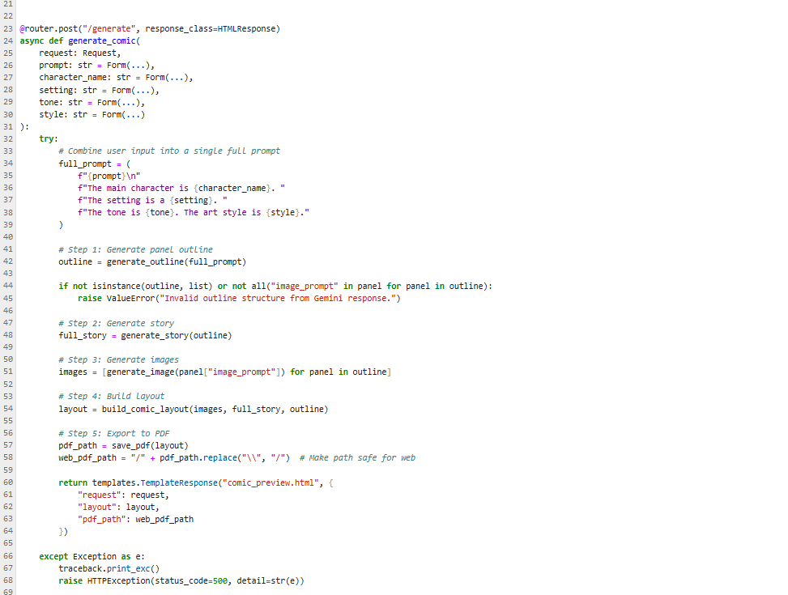

Export Success Route:
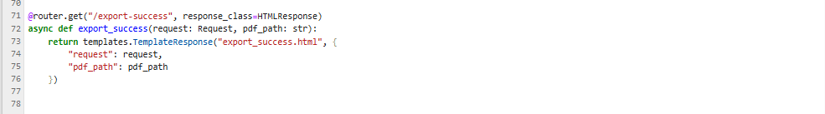

Image generation Route:
